**How to create virtual machine in virtual box**

1. Click new button

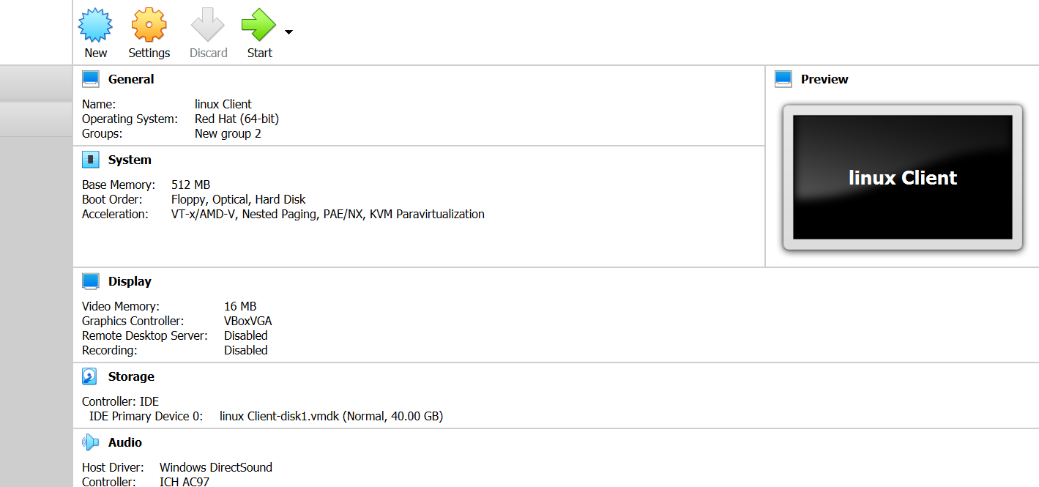

1. Enter name, select machine type and select version

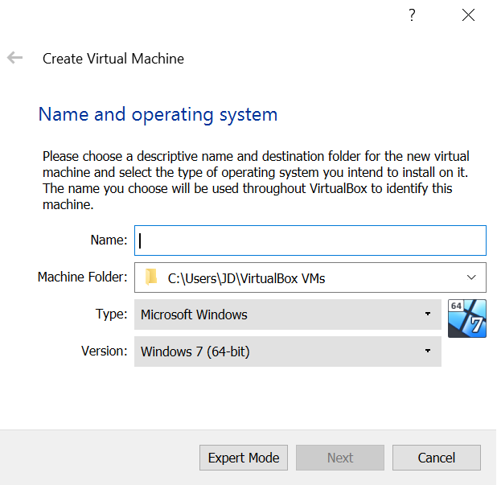

1. Select memory size if you required -> -> click on next button

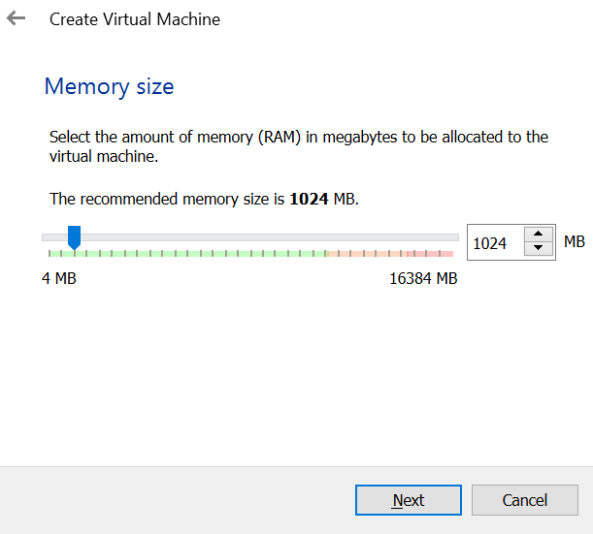

1. 4.Select hard disk type -> Create a virtual hard disk now -> click on next button

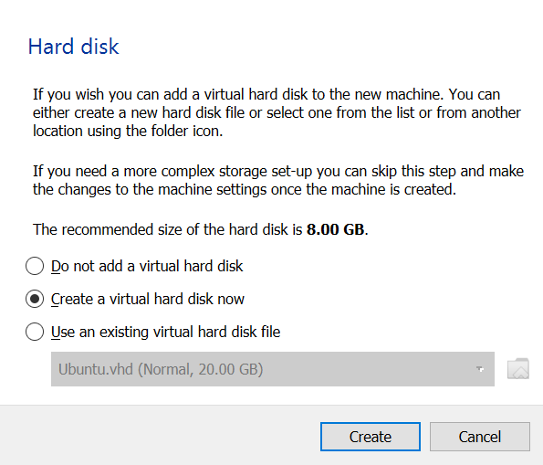

1. Select hard disk fil type -> VDI -> click on next button

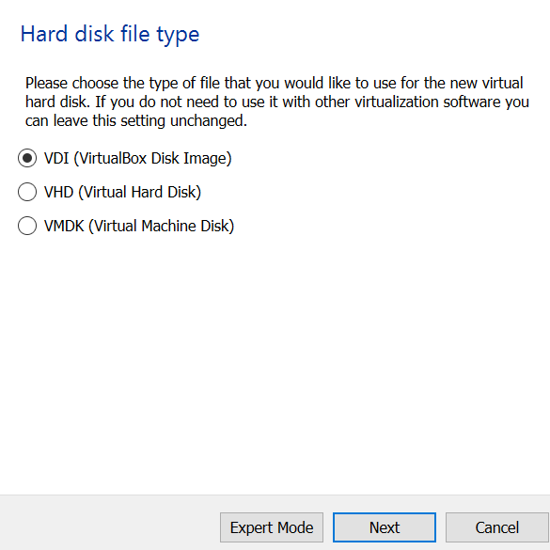

1. Select Storage on physical hard disk -> Dynamically allocated -> click on next button

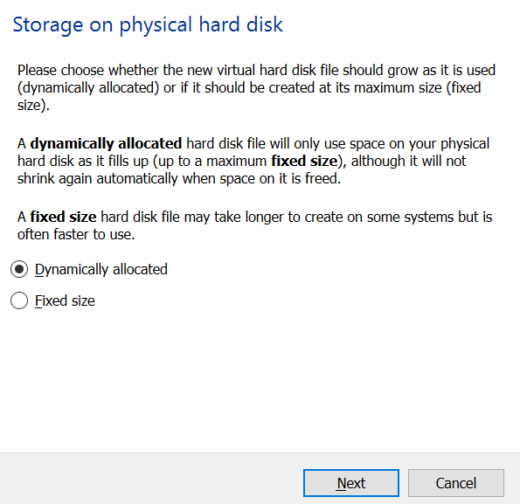

1. Enter file location and size -> click on create button

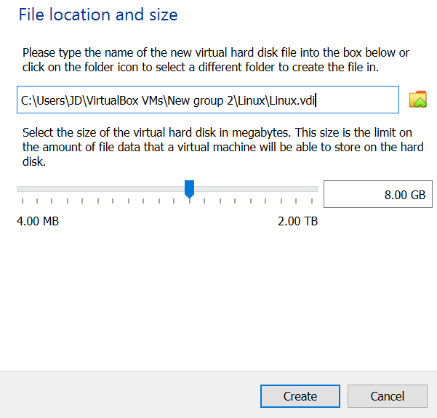

1. Select chose a disk file in storage option

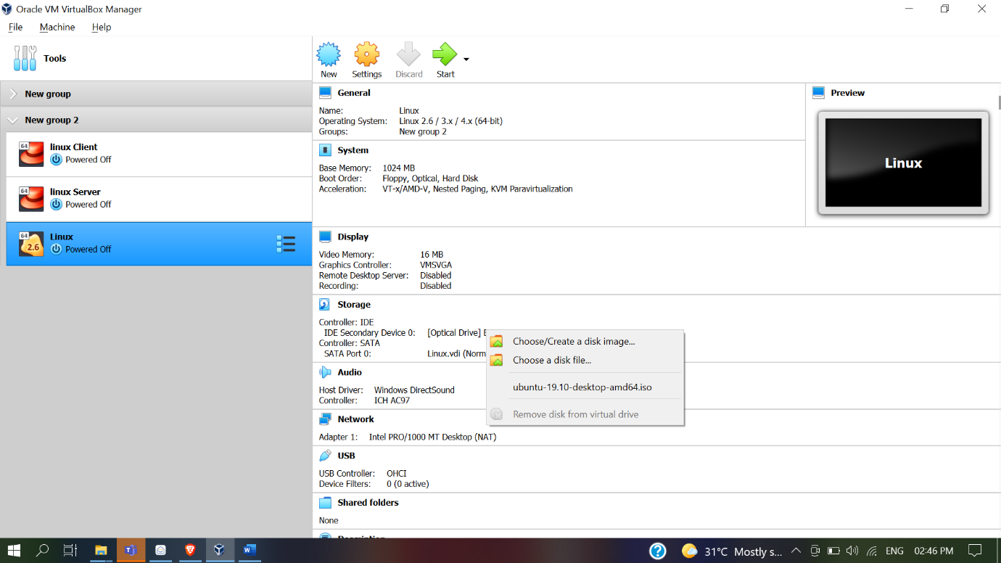

1. Click on Start button

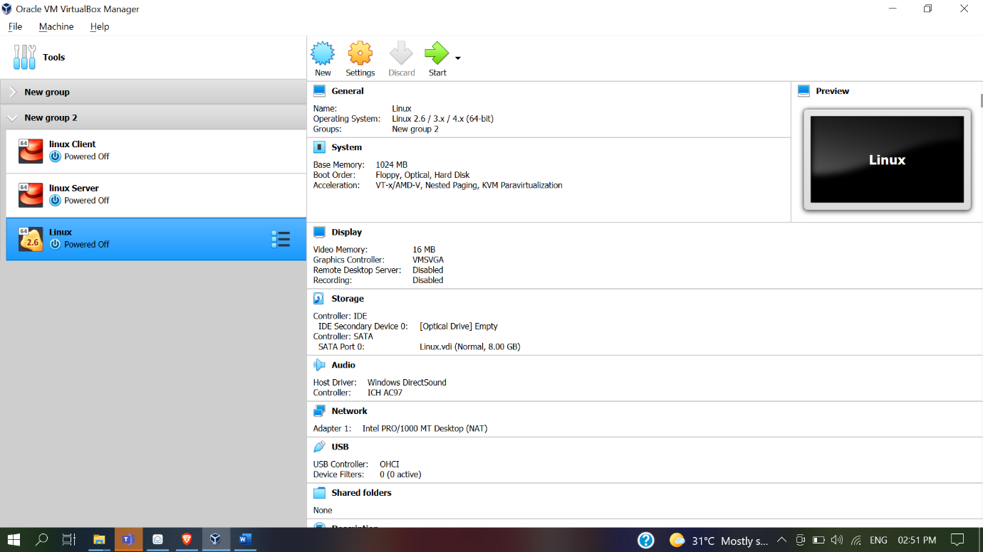

**Install Ubuntu in virtual box**

1. Click install ubuntu button

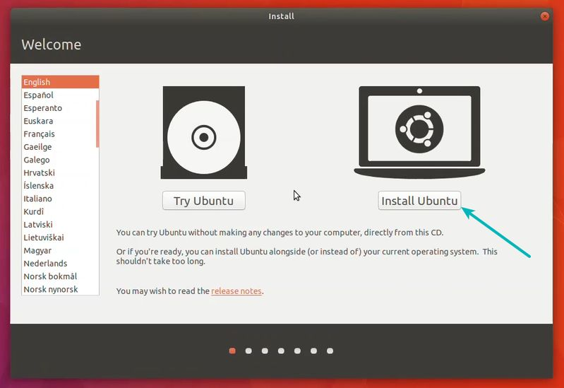

1. Click on Install third-party software check box -> click on continue button

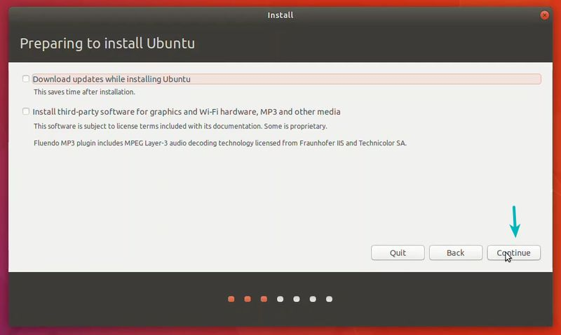

1. Erase disk and install Ubuntu -> click on Install Now button

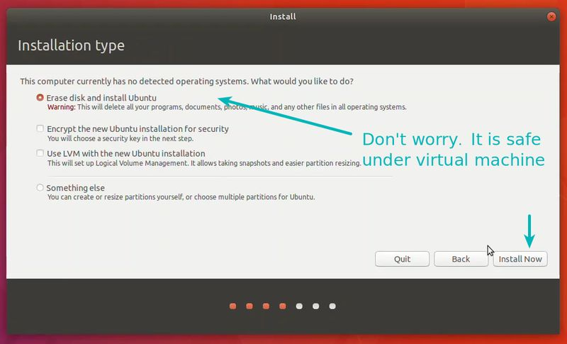

1. Click on Continue button

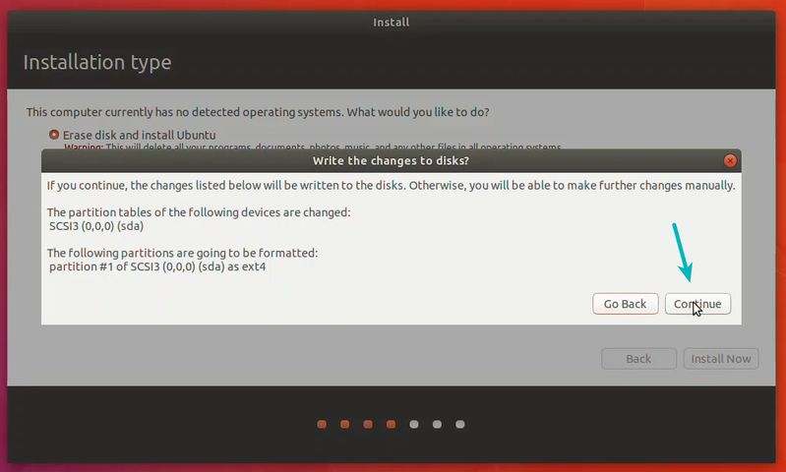

1. Select where are you location

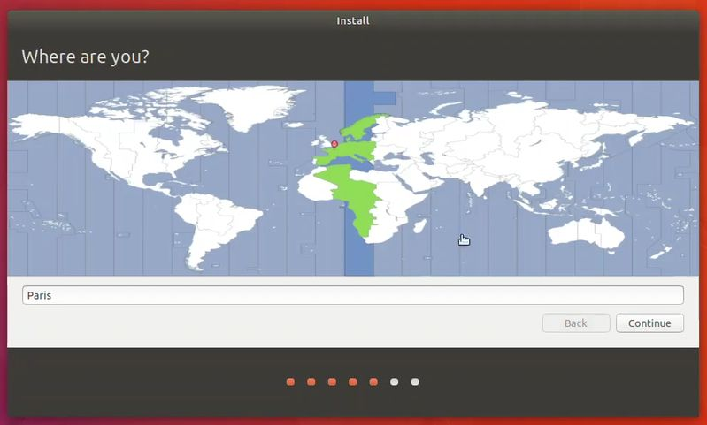

1. Select Keyboard layout -> click on continue

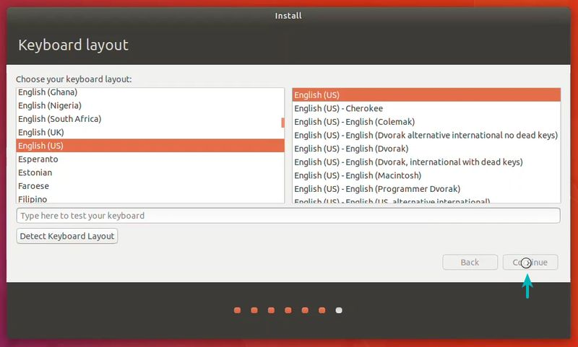

1. Enter your name ,password , confirm password -> click on continue button

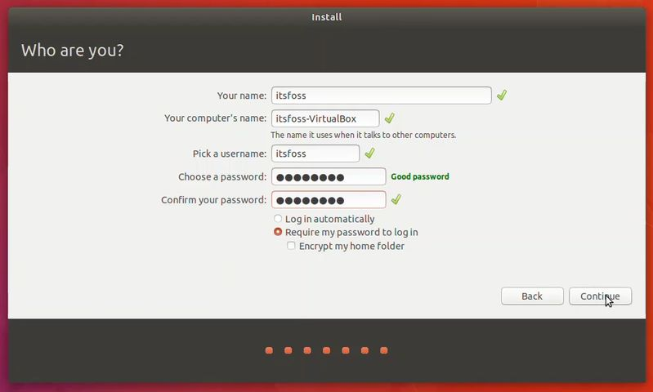

1. You are almost done. It will take 15- 20 min to complete the installation

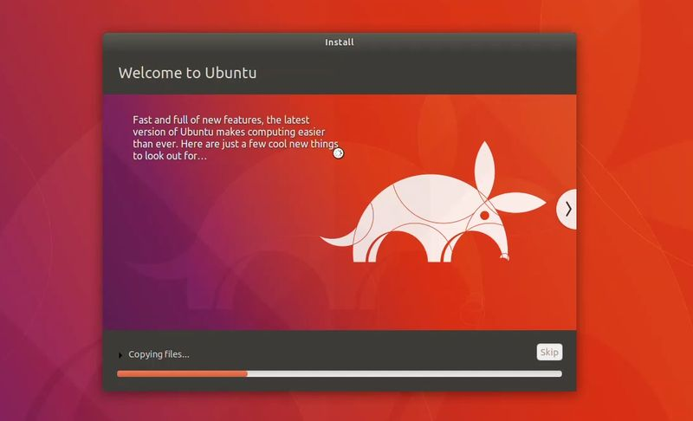

1. Once the installation finishes, restart the virtual machine

